UNIT ONE: CARING FOR OUR WORLD

Lesson 3: Let’s Recycle Our Trash

“The Journey of an Empty Soda Bottle”

On a summer evening, the whole family was watching a movie on television. Walid was drinking a nice cool soda bottle. When he finished, he put me, the empty bottle, in the trash can. That was the beginning of my journey. This is what happens to empty bottles when people throw them in trashcans.

People put bottles like me outside in the big garbage dumpster along with other things people don’t want, like plastic bags and boxes, metal cans, carboard boxes and leftover food.

A big garbage truck stops near the dumpster. Two men, who usually ride at the back, empty the dumpster in the truck. Then the truck makes some more stops to pick more garbage before it goes to a big plant just outside the city. There it dumps the garbage into a big machine called the sorter.

The sorter separates the garbage. The paper goes with all the other paper. The tin cans go with all the other cans and I go with all the other bottles. When all of us bottles are finally together, some men come and start dividing us into groups. How do you think they divide us? By size, shape, or color? By color! You're right. We usually come in green, brown, or clear, like me.

I, with the bottles like me, go into a machine that breaks us into little pieces. Now, I am no longer a bottle. I am little pieces of glass that look almost like sand. Can you guess what will happen to these little pieces next?

The small pieces of glass are sent to a special factory that melts them and makes new bottles! This is called ***glass recycling***.

Recycling is very important for all of you. People may recycle many other things that they throw away. Can you think of other things that you throw away and can be recycled?

Name: ______________________________ Date: ___________________

**Look at the words coming out of the glass bottle. They tell how glass is recycled. Use the words to make sentences that explain the process. Use words like first, next, then, other that, and finally to help you show the order.**

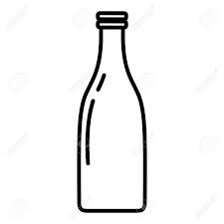

**__________________________________________________________________________________________________________________________________________________________________________________________________________________________________________**

**__________________________________________________________________________________________________________________________________________________________________________________________________________________________________________**

**__________________________________________________________________________________________________________________________________________________________________________________________________________________________________________**

Name: ______________________________ Date: ___________________

**Read the following sentences. They tell you how aluminum cans are recycled. Put the steps in order.**

* Finally, special machines cut each aluminum sheet into dishes (round shapes) and the dishes are used to make new cans.
* Garbage collectors bring the aluminum cans to collection centers. There, special machines crush them and put them into bundles.
* Then the liquid is cooled and made into bars. In the mill, machines roll the bars into sheets.
* Other machines heat the small pieces to remove the coating and the moisture. Then furnaces melt the small pieces into liquid.
* In a special plant, machines shred the crushed cans into small pieces.

**__________________________________________________________________________________________________________________________________________________________________________________________________________________________________________**

**__________________________________________________________________________________________________________________________________________________________________________________________________________________________________________**

**__________________________________________________________________________________________________________________________________________________________________________________________________________________________________________**

Name: ______________________________ Date: ___________________

1. **Write “S” if the group of words form a sentence. Write “F” if they form an fragment.**
2. Plastic can be recycled. ______
3. Sort the plastic into similar groups. _____
4. Then the plastic. ______
5. The clean plastic into flakes. ______
6. Other machines melt the flakes into small rounded shapes called pellets. ______
7. Are melted and shaped into the new final product. ______
8. **Complete the sentence fragments in the exercise above. Use the parts from the box. write the sentences in a paragraph form.**

* is cleaned
* special machines cut
* finally, these pellets
* workers

**__________________________________________________________________________________________________________________________________________________________________________________________________________________________________________**

**__________________________________________________________________________________________________________________________________________________________________________________________________________________________________________**

**__________________________________________________________________________________________________________________________________________________________________________________________________________________________________________**

Name: ______________________________ Date: ___________________

1. 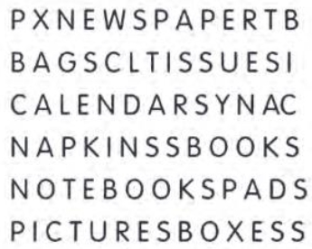**Look at the puzzle. Circle 10 words that name things made of paper.**
2. **You use a lot of paper every day. Write the names of paper products you use in the first column. The words you found in exercise A may help you. In the second column write what you use them for.**

|  |  |
| --- | --- |
| **Things made from paper** | **I use them** |
| *Paper napkins* | *to wipe hands* |

1. **Use the list in the first column to complete the sentences below.**
2. The things I can reuse are: ____________________________________________________
3. The things I can recycle are: __________________________________________________
4. The things I can reduce are: ___________________________________________________